Thank you, 2018 Symposium Sponsors

Symposium Sponsor
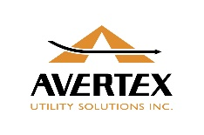
Avertex Utility Solutions Inc

Room Key Sponsor
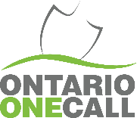
Ontario One Call

Name Badge Sponsor
Vivax Canada Inc

Symposium Bag Sponsor
multiVIEW Locates Inc

Awards Luncheon
Aecon Utilities

Hockey Challenge
TransCanada

Breakfast Sponsor
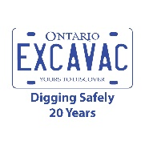
Ontario Excavac Inc.

Closing Luncheon
Enbridge Gas Distribution
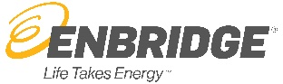

ORCGA Corn Hole
TransCanada

Vendor Passport
TelDig Inc.
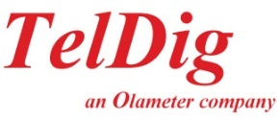

Coffee Break Sponsors

Planview Utility Services Inc MetaFlo Technologies Inc. Vivax Canada Inc.

Would you like to become a 2018 Symposium Sponsor?
Download the commitment form below

